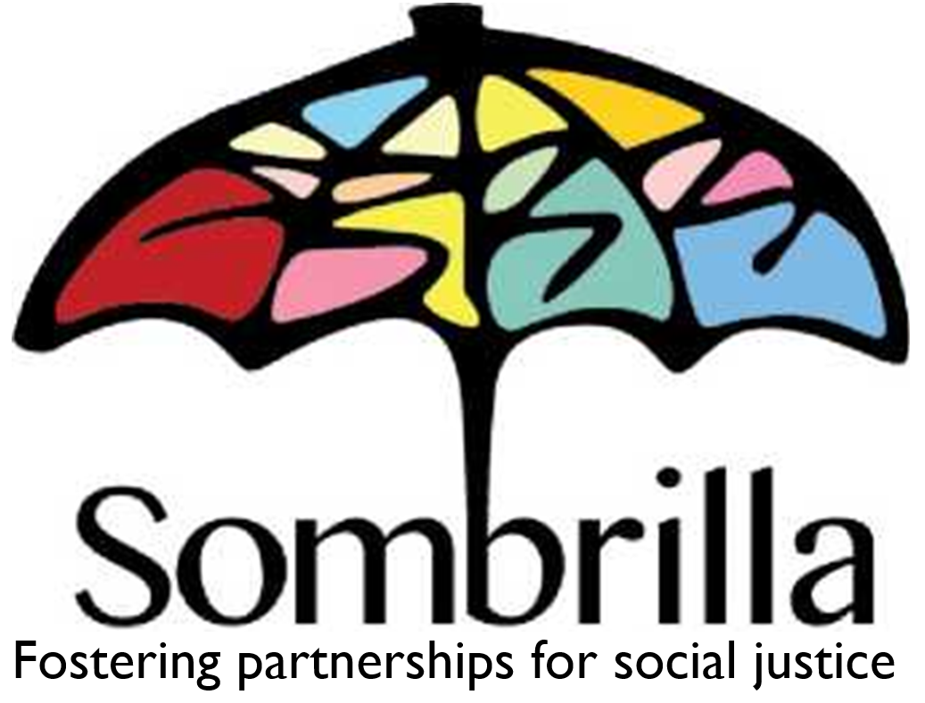
Charity Registration Number: 89012 7673 RR 0001

Too busy to bake this Christmas?
Let us take care of it!

This Christmas, let us take care of your baking with delicious and beautifully presented home-made recipes!
Proceeds from this Bake Sale will go to Sombrilla.
Sombrilla is an Alberta-based, non-governmental organization founded in 1985. We partner with communities in Latin America to empower them and facilitate human rights, social justice, sustainable development and gender equality

Cookies | Price per Dozen | Quantity (in dozens) | Total
Gingersnap Cookies | $12.00
Sugar cookies (with icing) | $14.00
Sugar cookies (no icing) | $12.00
Shortbread cookies | $12.00
 |  | Cookies Subtotal
Platters and Tins | Price per Tray/Tin | Quantity | Total
Small Assorted Platter (25 pieces*) | $25.00
Large Assorted Platter (50 pieces*) | $50.00
Tin of Kididdle  (Golden Grahams in white chocolate) | $14.00
* platters include 3 types of cookies, chocolate “haystacks”, and kididdle |  | Platter & Tin Subtotal
 |  | Grand Total

Name |  |  |  |  | Phone No.
Address |  |  |  |  | City
Province | AB | Postal Code |  |  | Email*
*email address will only be used to remind of pick-up date

Sombrilla Contact:

Picking Up Order |  |  | Delivery Required

Pick Up Dates: | Thursday Dec 8th – Friday Dec 9th (location arranged with your Sombrilla Contact)  Sunday, December 10th 2 to 5 PM – At Sombrilla’s Annual Choclotada Celebration  11424-77ave., Edmonton Alberta

